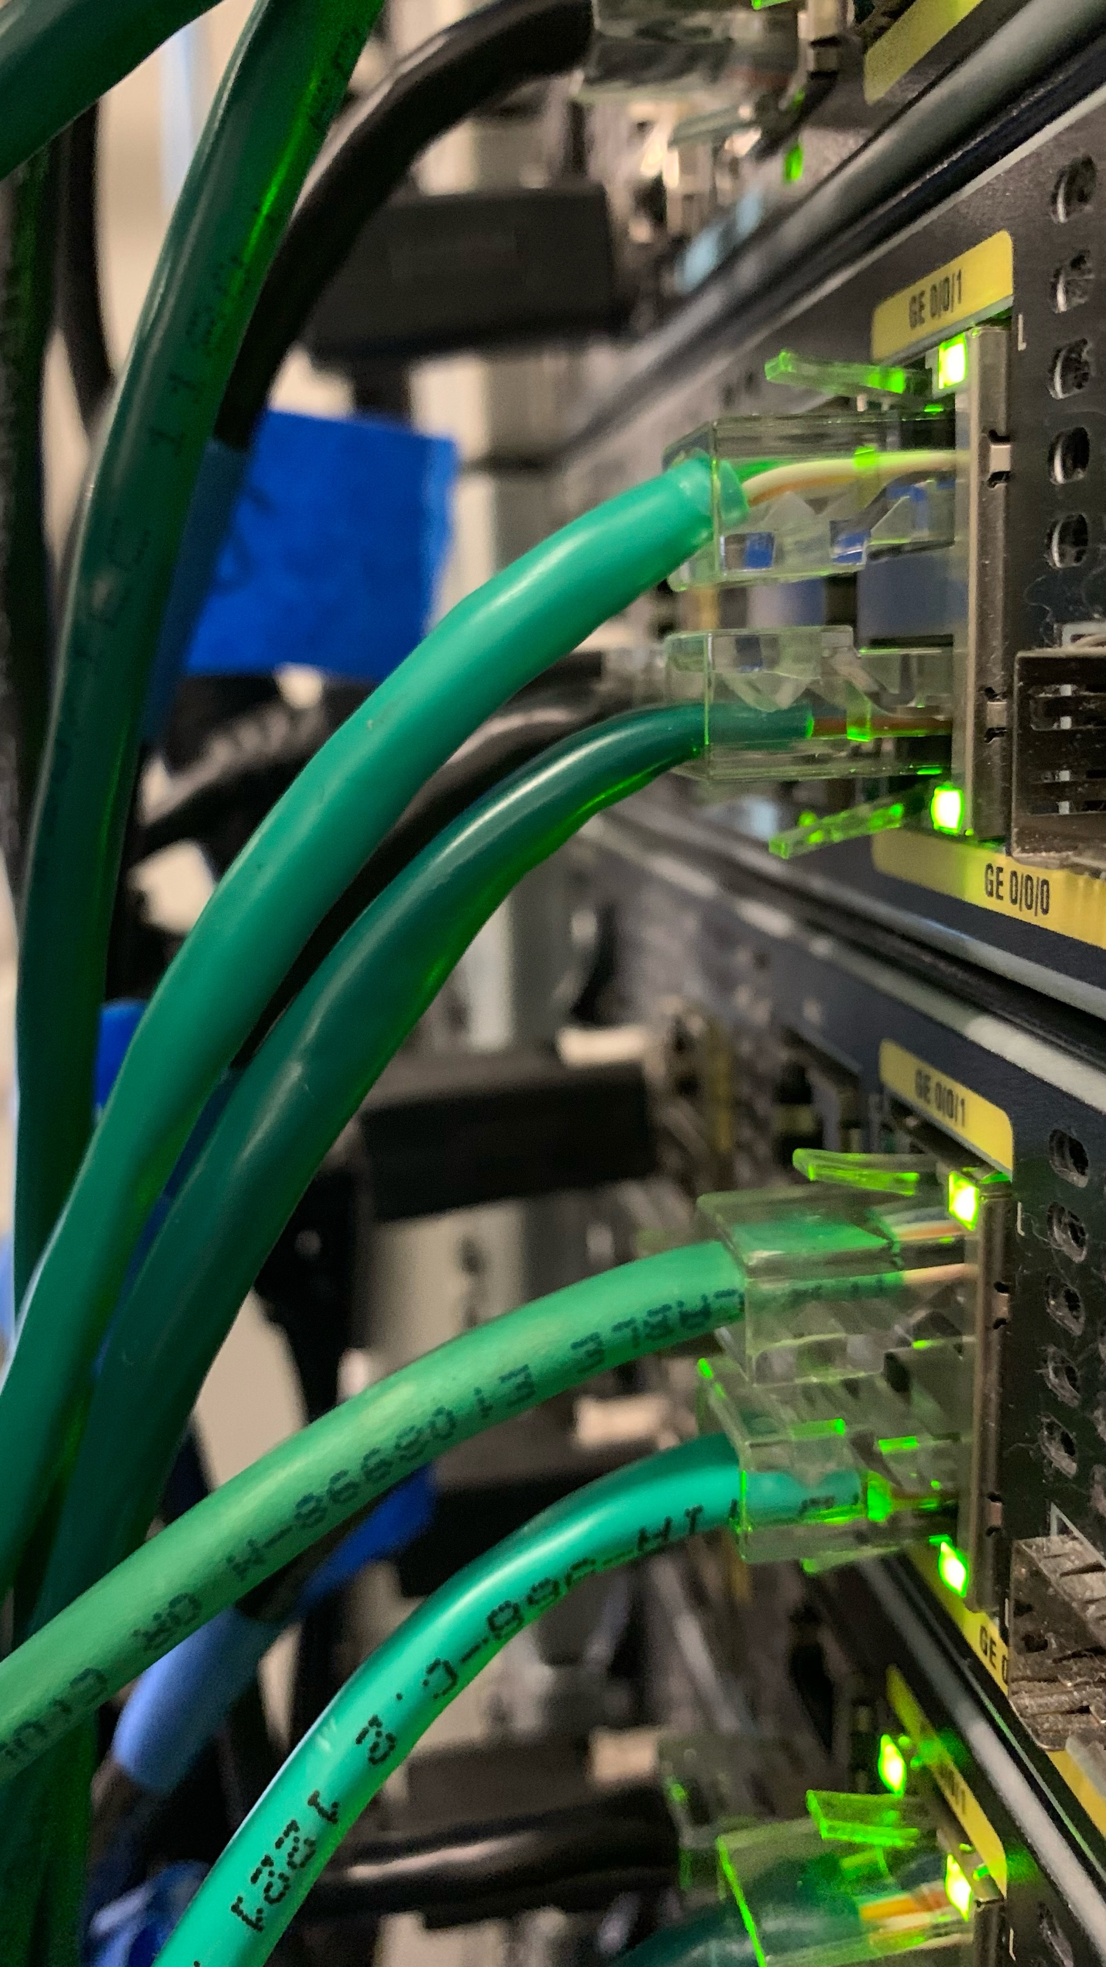

Setting Up BGP Between Networks
By Eric Xia
Purpose
The purpose of this lab is to configure BGP to work with three different networks, specifically OSPF, EIGRP, and IS-IS (very poorly named, I know). Additionally, this will feature both IPv4 and IPv6 configurations for each, and the end goal is to ping from one end of the topology to the other using the BGP configurations.
Background
BGP
BGP, also known as Border Gateway Protocol, is an external gateway routing protocol that is designed to connect different routing protocols together and create routes in between routers that don’t have other routing protocols between them. BGP essentially works as a bridge between 2 bordering protocols and as a translator between the 2 protocols, providing routes between the borders. By doing so, you can ping a router that is 5 routers and 3 routing protocols away from you, along with connecting each branch of a company’s network together, especially if they run on different routing protocols.
BGP essentially was developed starting in the late-1980s, back when there still were very simple routing protocols (such as EGP). In fact, in 1989, BGP-1 was introduced to replace the aging, old, and far too simple EGP. During its early years, BGP evolved very quickly, with BGP-2 releasing in 1990 and BGP-3 releasing in 1991 to fix issues and improve on previous iterations. In 1994, BGP-4 releases, and adds support for Classless Inter-Domain Routing (CIDR) along with introducing the modern path-vector model. In the late 90s, BGP-4 gets improved on, but stays, with variations such as MP-BGP (for IPv6) and improvements such as traffic engineering, communities, route filtering, and policy control. Nowadays, BGP is known to have some security issues, but improvements on the security side for BGP come out and are known as RPKI and BGPsec.
OSPF
OSPF, also known as Open Shortest Path First, is an interior gateway routing protocol that is one of the most widely used protocols out there, known for minimising routing distance between routers. It is known for using the SPF/Dijkstra compute model for routing. Oftentimes, it would the shortest and most direct route using its routing table, which then goes to the second shortest route if the shortest route goes down, and so on and so on until it reaches its gateway of last resort. The reason why it is so popular is because it has an extremely high scalability, with both tiny 10-person companies and huge corporates using it. It can also be separated into single-area OSPF and multi-area OSPF, with multi-area OSPF being better for larger networks, whereas single-area OSPF would be better for closer integration.
OSPF is also known for having fast convergence, measuring using bandwidth (measured in cost), being classless, being hierarchical (with area 0 being the backbone), and supporting ECMP (load-balancing).
EIGRP
EIGRP, also known as Enhanced Interior Gateway Routing Protocol, is an interior gateway routing protocol that is mainly used inside Cisco-heavy organisations. It initially was Cisco-proprietary but eventually opened and now can be used on all different brands of routers and is currently partially open-source. It’s often called a hybrid protocol, since it uses both distance-vector routing and link state behaviour.
It works by neighbours sending partial updates, picking best paths and then good backup paths, and maintaining 3 tables: a neighbour table, a topology table, and a routing table. Like OSPF, it uses bandwidth to calculate its metrics, but also uses delay, which makes it faster than OSPF when it comes to route switching. It’s has its advantages over OSPF, with it being way faster when it comes to failover latency and has a very simple configuration in Cisco-heavy networks. It isn’t as popular compared to OSPF, because it’s historically known to be limited depending on the brand, making it much less common in multi-branded router environments (with not many Cisco routers or EIGRP-compatible routers), and it also has a lack of areas, which OSPF does not lack.
IS-IS
IS-IS, also known as Intermediate System to Intermediate System, is a catastrophically named (I mean who came up with this abbreviation) interior gateway routing protocol whose name as aged as well as Windows Millenium Edition right after Windows XP released, often used inside autonomous systems. It is very popular with ISPs and large service provider networks due to its ability to run in autonomous systems. It is also very well known that its name has poorly aged due to its association with a very certain organisation.
That aside, it works by treating routers as intermediary systems that exchange link-state PDUs, and that everyone builds from the same topology database. Something else to note is that updates in IS-IS is event-driven and not periodic. Its design is like OSPF in which it uses a two-level hierarchy, where Level-1 is intra-area routing, and Level-2 is inter-area routing. It is also classless and supports CIDR, just like OSPF. It also supports ECMP, and only use cost for its metrics, making it extremely predictable. It is used often due to its stability at scale, less updates than OSPF, and runs directly on layer 2, meaning that both IPv4 and IPv6 can run natively. Suspicious name aside, it does have its downsides since it looks weird compared to OSPF, and that it is much harder to configure compared to EIGRP or OSPF. Also, despite being one of the most stable and most convenient IGPs in existence, IS-IS still suffers from a very catastrophic naming abbreviation that creates a lot of discomfort and at least one “no, it’s not that organisation” clarification per discussion.
Lab Summary
In this lab, my lab partner and I set up 3 2-router networks that are each connected to each other, totalling up to 6 devices. The first 2 routers ran on OSPF, the next 2 routers ran on EIGRP, and the final 2 routers ran on IS-IS. There was a BGP link between routers 2 and 3, and another BGP link between routers 3 and 4. We also ran OSPFv3 on the first 2 routers and EIGRP for IPv6 on the next 2 routers. Since IS-IS ran IPv6 natively, we didn’t need to configure any extra protocol for it. That aside, we also did the basic router configs for each router, which included naming the router, setting security passwords for each router, and setting up MOTD for them. Afterwards, we tested to see if the pings went through from the first router to the last router and then verified that it was using BGP by tracerouting it and showing the IP routes.
Network Diagrams
IPv4:
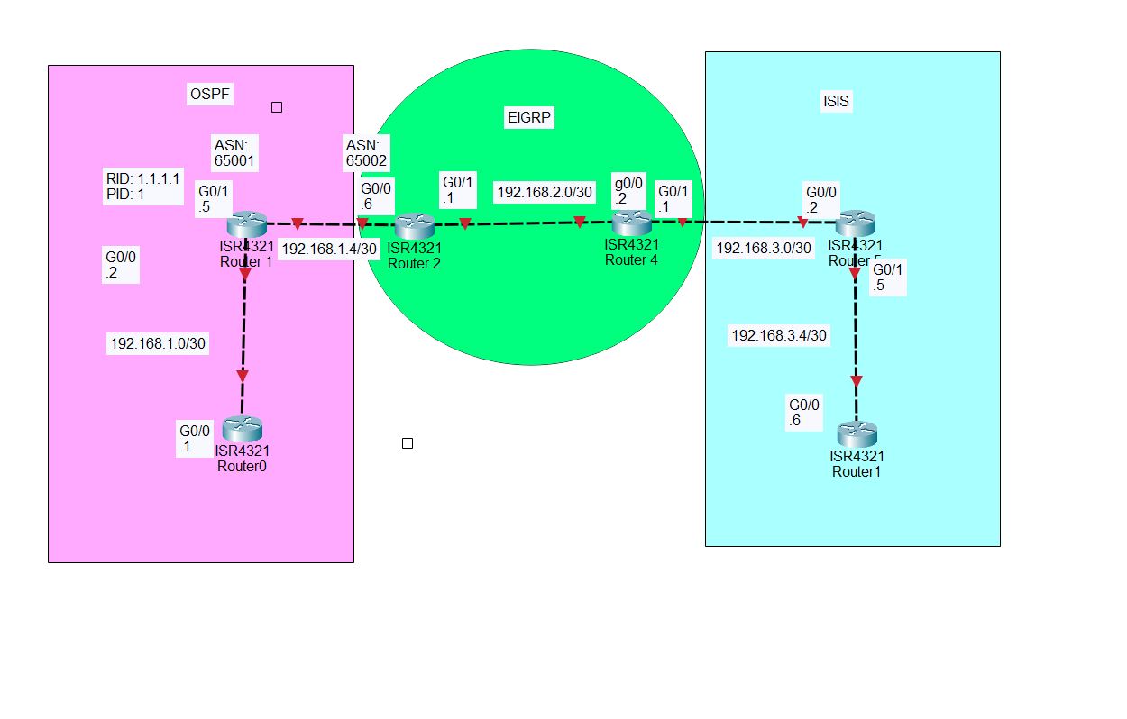
IPv6:
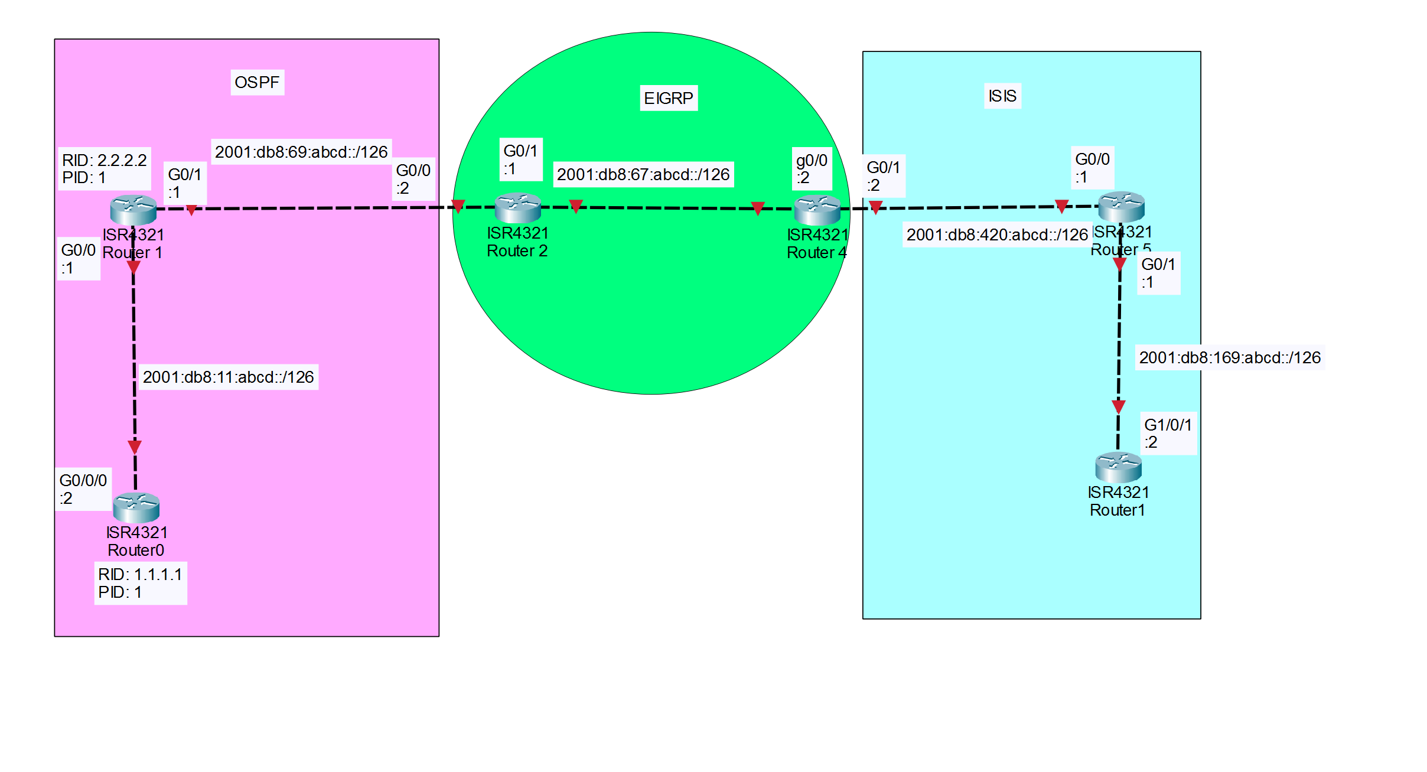
Step-by-step guide
Step 1
First, we start off with the most basic router configurations. This includes setting passwords and naming the switch (please first do enable and then conf t!)
This applies to every single router
Command | Description
hostname xxx | Sets the hostname of the device
line con 0  password cisco  login  exit | Sets the device password
line vty 0 15  password cisco  login  exit | Sets the line vty 0 4 and line vty 5 15 passwords (both at the same time)
enable secret class | Sets the password for entering privileged exec mode
banner motd #unauthorised access is prohibited and can be punishable# | Sets the banner message that shows when entering the device
ipv6 unicast-routing | Allows for the IPv6 addresses to be set inside interfaces
Step 2
Now it’s time to set the rest of the basic configs onto each of the routers. This includes the IPv4 and IPv6 addresses, and on the proper ports they should be on.
IPv4:
 | R1 | R2 | R3 | R4 | R5 | R6
G0/0/0 | 192.168.1.1 | 182.168.1.2 | 192.168.1.6 | 192.168.2.2 | 192.168.3.2 | 192.168.3.6
G0/0/1 | N/A | 192.168.1.5 | 192.168.2.1 | 192.168.3.1 | 192.168.3.5 | N/A
Lo0 | N/A | N/A | 3.3.3.3 | 4.4.4.4 | 5.5.5.5 | 6.6.6.6
Note that for all g0/0/x subnets are 255.255.255.252 (/30), and for all loopback interfaces subnets are 255.255.255.255 (/32)
IPv6:
 | R1 | R2 | R3 | R4 | R5 | R6
G0/0/0 | 2001:db8:11:abcd::2 | 2001:db8:11:abcd::1 | 2001:db8:69:abcd::2 | 2001:db8:67:abcd::2 | 2001:db8:420:abcd::1 | 2001:db8:169:abcd::2
G0/0/1 | N/A | 2001:db8:69:abcd::1 | 2001:db8:67:abcd::1 | 2001:db8:420:abcd::2 | 2001:db8:169:abcd::1 | N/A
Note that for all g0/0/x subnets are /126.
Commands:
Command | Description
int g0/0/x  ip add 192.168.x.x 255.255.255.252  ipv add 2001:db8:xxx:abcd::x/126  no shut | Sets the IPv4 and IPv6 address for each interface.
int lo0  ip add x.x.x.x 255.255.255.255 | Sets the loopback interface (primarily for troubleshooting)
Step 3
Now, it’s time to set each of the individual internal gateway protocols. Let’s start with OSPF on routers 1 and 2.
Router | Router-ID
R1 | 1.1.1.1
R2 | 2.2.2.2
Here are the commands:
Command | Description
router ospf 1  router-id x.x.x.x  redistribute connected | Sets the router ID for OSPF and redistributes all the IP routes
ipv6 router ospf 1  router-id x.x.x.x  redistribute connected | Sets the router ID for OSPFv3 and redistributes all the IPv6 routes
int g0/0/0  ip ospf 1 area 0  ipv6 ospf 1 area 0 | Connects OSPF and OSPFv3 into the desired interface
Step 4
Now, it’s time to set EIGRP on routers 3 and 4.
Command | Description
router eigrp 100  network 3.3.3.3 0.0.0.0  network 4.4.4.4 0.0.0.0  network 192.168.2.0 0.0.0.3  passive-interface default  no passive-interface g0/0/x  no passive-interface lo0 | Sets the EIGRP networks, also disables passive interface for certain interfaces so it shows on the routes. It’s g0/0/1 for R3 and g0/0/0 for R4.
int g0/0/x  bandwidth 100000  ip eigrp 100  ipv6 eigrp 100 | Sets the interface up for EIGRP. It’s g0/0/1 for R3 and g0/0/0 for R4.
Now, note here that the EIGRP uses loopback interfaces for troubleshooting.
Step 5
Now, it’s time to set up IS-IS on routers 5 and 6.
Command | Description
router isis 1  net xx.000x.0000.0000.000x.00  is-type level-1  metric-style wide  redistribute connected | Sets up the IS-IS setup, also redistributing the routes at the same time  Sets up a net entry title for the router  Manually set IS-IS to run on level-1 and not level-1-2
int g0/0/x  ip router isis 1 | Adds in IS-IS into the specified interface. It’s g0/0/1 for R5 and g0/0/0 for R6.
int lo0  ip router isis 1 | Adds in IS-IS into the loopback interface for troubleshooting reasons.

Step 6
Now, it’s time to set up BGP between routers.
Let’s work with configurations between R2 and R3 and between R4 and R5.
Command | Description
router bgp 6500x  bgp log-neighbor-changes  neighbor 2001:DB8:xx:ABCD::x remote-as 6500x  neighbor 192.168.x.x remote-as 6500x | Sets up BGP for the router (not set in interface yet), sets the neighbour address for both IPv4 and IPv6.  The BGP number is 65001 for R2, 65002 for R3, 65003 for R4, and 65004 for R5. The neighbouring router will be the number that isn’t assigned to the router itself and instead will be the other number.
(in router bgp 6500x)  address-family ipv4  redistribute connected  redistribute ospf 1  neighbor 192.168.x.x activate | Sets the neighbours and address family for IPv4, along with redistributing the routes from the OSPF side of things.
address-family ipv6  redistribute connected  redistribute ospf 1  neighbor 2001:DB8:xx:ABCD::x activate | Sets the neighbours and address family for IPv4, along with redistributing the routes from the OSPFv3 side of things.
Note that all interfaces here apply for every one of them.
Step 7
Since each router runs a different IGP, the configs will be slightly different.
R2
Command | Description
router ospf 1  redistribute connected subnets  redistribute bgp 65001 subnets | Redistributes the discovered BGP routes into the routing database for IPv4, allowing for OSPF to route outside of the network.
ipv6 router ospf 1  redistribute connected  redistribute bgp 65001 | Redistributes the discovered BGP routes into the routing database for IPv6, allowing for OSPFv3 to route outside of the network.
R3 and R4
Command | Description
router eigrp 100  redistribute bgp 6500x metric 10000 100 255 1 1500  redistribute connected | Redistributes the BGP routes into the routing database for EIGRP to work with, allowing for EIGRP to route outside the network for both IPv4 and IPv6. The BGP number is 65002 for R3 and 65003 for R4.

R5
Command | Description
router isis 1  redistribute connected  redistribute bgp 65003 metric 1 level-1 | Redistributes the BGP routes into the routing database for IS-IS to work with, allowing for IS-IS to route outside of the network for both IPv4 and IPv6.
Congratulations! You have completed setup for BGP. Now, you only really need to do certain commands to see if the configurations work. Use traceroute and show ip route to verify that it’s working.
Configs
R1 (OSPF):
version 16.9
service timestamps debug datetime msec
service timestamps log datetime msec
platform qfp utilization monitor load 80
platform punt-keepalive disable-kernel-core
hostname R1
boot-start-marker
boot-end-marker
vrf definition Mgmt-intf
address-family ipv4
exit-address-family
address-family ipv6
exit-address-family
no aaa new-model
login on-success lo
subscriber templating
vtp domain cisco
vtp mode transparent
ipv6 unicast-routing multilink bundle-name
spanning-tree extend system-id
Redundancy
mode non
interface GigabitEthernet0/0/0
ip address 192.168.1.1 255.255.255.252
ip ospf 1 area 0
negotiation auto
ipv6 address 2001:DB8:11:ABCD::2/126
ipv6 ospf 1 area 0
interface GigabitEthernet0/0/1
no ip address
negotiation auto
interface GigabitEthernet0/2/0
no ip address
negotiation auto
interface GigabitEthernet0/2/1
no ip address
negotiation auto
interface GigabitEthernet0
vrf forwarding Mgmt-intf
no ip address
negotiation auto
router ospf 1
router-id 1.1.1.1
ip forward-protocol nd
no ip http server
ip http secure-server
ipv6 router ospf 1
router-id 1.1.1.1
control-plane
line con 0
transport input none
stopbits 1
line aux 0
stopbits 1
line vty 0 4
login
end
R2 (OSPF + BGP):
version 16.9
service timestamps debug datetime msec
service timestamps log datetime msec
platform qfp utilization monitor load 80
platform punt-keepalive disable-kernel-core
hostname R2
boot-start-marker
boot-end-marker
vrf definition Mgmt-intf
address-family ipv4
exit-address-family
address-family ipv6
exit-address-family
no aaa new-model
login on-success log
subscriber templating
vtp domain cisco
vtp mode transparent
ipv6 unicast-routing
multilink bundle-name authenticated
license udi pid ISR4321/K9 sn FLM24060912
no license smart enable
diagnostic bootup level minimal
spanning-tree extend system-id
redundancy
mode none
interface GigabitEthernet0/0/0
ip address 192.168.1.2 255.255.255.252
ip ospf 1 area 0
negotiation auto
ipv6 address 2001:DB8:11:ABCD::1/126
Ipv6 ospf 1 area 0
interface GigabitEthernet0/0/1
ip address 192.168.1.5 255.255.255.252
negotiation auto
ipv6 address 2001:DB8:69:ABCD::1/126
interface GigabitEthernet0/2/0
no ip address
negotiation auto
interface GigabitEthernet0/2/1
no ip address
negotiation auto
interface GigabitEthernet0
vrf forwarding Mgmt-intf
no ip address
negotiation auto
router ospf 1
router-id 2.2.2.2
redistribute connected subnets
redistribute bgp 65001 subnets
router bgp 65001
bgp log-neighbor-changes
neighbor 2001:DB8:69:ABCD::2 remote-as 65002
neighbor 192.168.1.6 remote-as 65002
address-family ipv4
redistribute connected
redistribute ospf 1
no neighbor 2001:DB8:69:ABCD::2 activate
neighbor 192.168.1.6 activate
exit-address-family
address-family ipv6
redistribute connected
redistribute ospf 1
neighbor 2001:DB8:69:ABCD::2 activate
exit-address-family
ip forward-protocol nd
no ip http server
ip http secure-server
ip tftp source-interface GigabitEthernet0
ipv6 router ospf 1
router-id 2.2.2.2
redistribute connected
redistribute bgp 65001
control-plane
line con 0
transport input none
stopbits 1
line aux 0
stopbits 1
line vty 0 4
login
end
R3 (BGP + EIGRP):
version 16.9
service timestamps debug datetime msec
service timestamps log datetime msec
platform qfp utilization monitor load 80
platform punt-keepalive disable-kernel-core
hostname r3
boot-start-marker
boot system bootflash:isr4300-universalk9.16.09.08.SPA.bin
boot-end-marker
vrf definition Mgmt-intf
address-family ipv4
exit-address-family
Address-family ipv6
exit-address-family
no aaa new-model
login on-success log
subscriber templating
vtp domain cisco
vtp mode transparent
ipv6 unicast-routing
multilink bundle-name authenticated
license udi pid ISR4321/K9 sn FDO214420G7
no license smart enable
diagnostic bootup level minimal
spanning-tree extend system-id
redundancy
mode none
interface Loopback0
description eigrp test
ip address 3.3.3.3 255.255.255.255
interface GigabitEthernet0/0/0
description bgp
ip address 192.168.1.6 255.255.255.252
negotiation auto
ipv6 address 2001:DB8:69:ABCD::2/126
interface GigabitEthernet0/0/1
description eigrp
Bandwidth 100000
ip address 192.168.2.1 255.255.255.252
negotiation auto
ipv6 address 2001:DB8:67:ABCD::1/126
ipv6 eigrp 100
interface Serial0/1/0
no ip address
shutdown
interface Serial0/1/1
no ip address
shutdown
interface GigabitEthernet0
vrf forwarding Mgmt-intf
no ip address
shutdown
negotiation auto
router eigrp 100
network 3.3.3.3 0.0.0.0
network 4.4.4.4 0.0.0.0
network 192.168.2.0 0.0.0.3
redistribute bgp 65002 metric 10000 100 255 1 1500
redistribute connected
passive-interface default
no passive-interface GigabitEthernet0/0/1
no passive-interface Loopback0
router bgp 65002
bgp log-neighbor-changes
neighbor 2001:DB8:69:ABCD::1 remote-as 65001
neighbor 192.168.1.5 remote-as 65001
neighbor 192.168.2.2 remote-as 65002
address-family ipv4
redistribute connected
redistribute eigrp 100
no neighbor 2001:DB8:69:ABCD::1 activate
neighbor 192.168.1.5 activate
neighbor 192.168.1.5 weight 500
neighbor 192.168.2.2 activate
neighbor 192.168.2.2 weight 300
exit-address-family
address-family ipv6
redistribute connected
redistribute eigrp 100
neighbor 2001:DB8:69:ABCD::1 activate
exit-address-family
ip forward-protocol nd
ip http server
ip http authentication local
ip http secure-server
ip tftp source-interface GigabitEthernet0
ip route 192.168.2.2 255.255.255.255 192.168.2.2 90
ipv6 router eigrp 100
redistribute connected
redistribute bgp 65002 metric 10000 100 255 1 1500
route-map BGP-TO-EIGRP permit 10
set metric 1000000 10 255 1 1500
set tag 52
route-map EIGRP-TO-BGP deny 5
match tag 52
control-plane
line con 0
transport input none
stopbits 1
line aux 0
stopbits 1
line vty 0 4
login
end
R4 (EIGRP + BGP):
version 16.9
service timestamps debug datetime msec
service timestamps log datetime msec
platform qfp utilization monitor load 80
platform punt-keepalive disable-kernel-core
hostname r4
boot-start-marker
boot-end-marker
vrf definition Mgmt-intf
address-family ipv4
exit-address-family
address-family ipv6
exit-address-family
no aaa new-model
login on-success log
subscriber templating
vtp domain cisco
vtp mode transparent
ipv6 unicast-routing
multilink bundle-name authenticated
license udi pid ISR4321/K9 sn FDO211216BL
no license smart enable
diagnostic bootup level minimal
spanning-tree extend system-id
redundancy
mode none
interface Loopback0
description eigrp test
ip address 4.4.4.4 255.255.255.255
interface GigabitEthernet0/0/0
description eigrp
bandwidth 100000
ip address 192.168.2.2 255.255.255.252
negotiation auto
ipv6 address 2001:DB8:67:ABCD::2/126
ipv6 eigrp 100
interface GigabitEthernet0/0/1
description bgp
ip address 192.168.3.1 255.255.255.252
negotiation auto
ipv6 address 2001:DB8:420:ABCD::2/126
interface Serial0/1/0
no ip address
interface Serial0/1/1
no ip address
interface GigabitEthernet0
vrf forwarding Mgmt-intf
no ip address
negotiation auto
router eigrp 100
network 3.3.3.3 0.0.0.0
network 4.4.4.4 0.0.0.0
network 192.168.2.0 0.0.0.3
redistribute bgp 65002 metric 10000 100 255 1 1500
no passive-interface GigabitEthernet0/0/0
no passive-interface Loopback0
router bgp 65002
bgp log-neighbor-changes
neighbor 2001:DB8:420:ABCD::1 remote-as 65003
neighbor 192.168.2.1 remote-as 65002
neighbor 192.168.3.2 remote-as 65003
address-family ipv4
redistribute eigrp 100
no neighbor 2001:DB8:420:ABCD::1 activate
neighbor 192.168.2.1 activate
neighbor 192.168.2.1 weight 300
neighbor 192.168.3.2 activate
neighbor 192.168.3.2 weight 500
neighbor 192.168.3.2 route-map PREF=ISIS in
exit-address-family
address-family ipv6
redistribute eigrp 100
neighbor 2001:DB8:420:ABCD::1 activate
exit-address-family
ip forward-protocol nd
no ip http server
ip http secure-server
ipv6 router eigrp 100
redistribute connected
redistribute bgp 65002 metric 10000 100 255 1 1500
route-map PREF=ISIS permit 10 set local-preference 300
control-plane
line con 0
transport input none
stopbits 1
line aux 0
stopbits 1
line vty 0 4
login
end
R5 (BGP + IS-IS):
Version 16.9
service timestamps debug datetime msec
service timestamps log datetime msec
platform qfp utilization monitor load 80
platform punt-keepalive disable-kernel-core
hostname R5
boot-start-marker
boot-end-marker
vrf definition Mgmt-intf
address-family ipv4
exit-address-family
address-family ipv6
exit-address-family
no aaa new-model
login on-success log
subscriber templating
vtp domain cisco
vtp mode transparent
ipv6 unicast-routing
multilink bundle-name authenticated
license udi pid ISR4321/K9 sn FDO214421CF
no license smart enable
diagnostic bootup level minimal
spanning-tree extend system-id
redundancy
mode none
interface Loopback0
ip address 5.5.5.5 255.255.255.255
ip router isis 1
interface GigabitEthernet0/0/0
ip address 192.168.3.2 255.255.255.252
negotiation auto
ipv6 address 2001:DB8:420:ABCD::1/126
interface GigabitEthernet0/0/1
ip address 192.168.3.5 255.255.255.252
ip router isis 1
negotiation auto
ipv6 address 2001:DB8:169:ABCD::1/126
interface Serial0/1/0
no ip address
interface Serial0/1/1
no ip address
interface GigabitEthernet0
vrf forwarding Mgmt-intf
no ip address
negotiation auto
router isis 1
net 49.0001.0000.0000.0005.00
is-type level-1
metric-style wide
redistribute connected
redistribute bgp 65003 metric 1 level-1
address-family ipv6
redistribute connected
redistribute bgp 65003
exit-address-family
router bgp 65003
bgp log-neighbor-changes
neighbor 2001:DB8:420:ABCD::2 remote-as 65002
neighbor 192.168.3.1 remote-as 65002
address-family ipv4
redistribute connected
redistribute isis 1 level-1
no neighbor 2001:DB8:420:ABCD::2 activate
neighbor 192.168.3.1 activate
exit-address-family
address-family ipv6
redistribute connected
redistribute isis 1 level-1
network 2001:DB8:67:ABCD::/126
neighbor 2001:DB8:420:ABCD::2 activate
exit-address-family
ip forward-protocol nd
control-plane
line con 0
transport input none
stopbits 1
line aux 0
stopbits 1
line vty 0 4
login
end
R6 (IS-IS):
version 16.9
service timestamps debug datetime msec
service timestamps log datetime msec
platform qfp utilization monitor load 80
platform punt-keepalive disable-kernel-core
hostname R6
boot-start-marker
boot-end-marker
vrf definition Mgmt-intf
address-family ipv4
exit-address-family
address-family ipv6
exit-address-family
no aaa new-model
login on-success log
subscriber templating
vtp domain cisco
vtp mode transparent
ipv6 unicast-routing
multilink bundle-name authenticated
license udi pid ISR4321/K9 sn FDO21441WBL
no license smart enable
diagnostic bootup level minimal
spanning-tree extend system-id
redundancy
mode none
interface Loopback0
ip address 6.6.6.6 255.255.255.255
ip router isis 1
interface GigabitEthernet0/0/0
ip address 192.168.3.6 255.255.255.252
ip router isis 1
shutdown
negotiation auto
ipv6 address 2001:DB8:168:ABCD::2/126
interface GigabitEthernet0/0/1
no ip address
shutdown
negotiation auto
interface Serial0/1/0
no ip address
shutdown
interface Serial0/1/1
no ip address
shutdown
interface GigabitEthernet0/2/0
no ip address
shutdown
negotiation auto
interface GigabitEthernet0/2/1
no ip address
shutdown
negotiation auto
interface GigabitEthernet0
vrf forwarding Mgmt-intf
no ip address
shutdown
negotiation auto
router isis 1
net 49.0001.0000.0000.0006.00
is-type level-1
metric-style wide
router isis
metric-style narrow
ip forward-protocol nd
ip http server
ip http authentication local
ip http secure-server
ip tftp source-interface GigabitEthernet0
control-plane
line con 0
transport input none
stopbits 1
line aux 0
stopbits 1
line vty 0 4
login
end
Test Results
Traceroute
R1 to R6
R1#traceroute 192.168.3.6
Tracing the route to 192.168.3.6
VRF info: (vrf in name/id, vrf out name/id)
1 192.168.1.2 1 msec 1 msec 0 msec
2 192.168.1.6 1 msec 1 msec 1 msec
3 192.168.2.2 1 msec 1 msec 1 msec
4 192.168.3.2 1 msec 2 msec 1 msec
5 192.168.3.6 1 msec 2 msec *
R6 to R1
R6#traceroute 192.168.1.1
Tracing the route to 192.168.1.1
VRF info: (vrf in name/id, vrf out name/id)
1 192.168.3.5 2 msec 1 msec 0 msec
2 192.168.3.1 0 msec 1 msec 1 msec
3 192.168.2.1 1 msec 1 msec 1 msec
4 192.168.1.5 2 msec 1 msec 1 msec
5 192.168.1.1 2 msec 2 msec *
Routing Tables
R1:
3.0.0.0/32 is subnetted, 1 subnets
O E2 3.3.3.3 [110/1] via 192.168.1.2, 23:10:38, GigabitEthernet0/0/0
4.0.0.0/32 is subnetted, 1 subnets
O E2 4.4.4.4 [110/1] via 192.168.1.2, 23:10:09, GigabitEthernet0/0/0
5.0.0.0/32 is subnetted, 1 subnets
O E2 5.5.5.5 [110/1] via 192.168.1.2, 23:04:38, GigabitEthernet0/0/0
6.0.0.0/32 is subnetted, 1 subnets
O E2 6.6.6.6 [110/1] via 192.168.1.2, 00:07:47, GigabitEthernet0/0/0
192.168.1.0/24 is variably subnetted, 3 subnets, 2 masks
C 192.168.1.0/30 is directly connected, GigabitEthernet0/0/0
L 192.168.1.1/32 is directly connected, GigabitEthernet0/0/0
O E2 192.168.1.4/30
[110/20] via 192.168.1.2, 23:10:50, GigabitEthernet0/0/0
192.168.2.0/30 is subnetted, 1 subnets
O E2 192.168.2.0 [110/1] via 192.168.1.2, 23:10:38, GigabitEthernet0/0/0
192.168.3.0/30 is subnetted, 1 subnets
O E2 192.168.3.4 [110/1] via 192.168.1.2, 00:08:17, GigabitEthernet0/0/0
R2:
3.0.0.0/32 is subnetted, 1 subnets
B 3.3.3.3 [20/0] via 192.168.1.6, 23:17:57
4.0.0.0/32 is subnetted, 1 subnets
B 4.4.4.4 [20/153856] via 192.168.1.6, 23:17:27
5.0.0.0/32 is subnetted, 1 subnets
B 5.5.5.5 [20/281856] via 192.168.1.6, 23:11:56
6.0.0.0/32 is subnetted, 1 subnets
B 6.6.6.6 [20/281856] via 192.168.1.6, 00:15:05
192.168.1.0/24 is variably subnetted, 4 subnets, 2 masks
C 192.168.1.0/30 is directly connected, GigabitEthernet0/0/0
L 192.168.1.2/32 is directly connected, GigabitEthernet0/0/0
C 192.168.1.4/30 is directly connected, GigabitEthernet0/0/1
L 192.168.1.5/32 is directly connected, GigabitEthernet0/0/1
192.168.2.0/30 is subnetted, 1 subnets
B 192.168.2.0 [20/0] via 192.168.1.6, 23:17:57
192.168.3.0/30 is subnetted, 1 subnets
B 192.168.3.4 [20/281856] via 192.168.1.6, 00:15:35
R3:
3.0.0.0/32 is subnetted, 1 subnets
C 3.3.3.3 is directly connected, Loopback0
4.0.0.0/32 is subnetted, 1 subnets
D 4.4.4.4 [90/153856] via 192.168.2.2, 23:19:28, GigabitEthernet0/0/1
5.0.0.0/32 is subnetted, 1 subnets
D EX 5.5.5.5 [170/281856] via 192.168.2.2, 23:13:39, GigabitEthernet0/0/1
6.0.0.0/32 is subnetted, 1 subnets
D EX 6.6.6.6 [170/281856] via 192.168.2.2, 00:16:47, GigabitEthernet0/0/1
192.168.1.0/24 is variably subnetted, 3 subnets, 2 masks
B 192.168.1.0/30 [20/0] via 192.168.1.5, 23:19:40
C 192.168.1.4/30 is directly connected, GigabitEthernet0/0/0
L 192.168.1.6/32 is directly connected, GigabitEthernet0/0/0
192.168.2.0/24 is variably subnetted, 2 subnets, 2 masks
C 192.168.2.0/30 is directly connected, GigabitEthernet0/0/1
L 192.168.2.1/32 is directly connected, GigabitEthernet0/0/1
192.168.3.0/30 is subnetted, 1 subnets
D EX 192.168.3.4
[170/281856] via 192.168.2.2, 00:17:17, GigabitEthernet0/0/1
R4:
3.0.0.0/32 is subnetted, 1 subnets
D 3.3.3.3 [90/153856] via 192.168.2.1, 23:19:55, GigabitEthernet0/0/0
4.0.0.0/32 is subnetted, 1 subnets
C 4.4.4.4 is directly connected, Loopback0
5.0.0.0/32 is subnetted, 1 subnets
B 5.5.5.5 [20/0] via 192.168.3.2, 23:14:10
6.0.0.0/32 is subnetted, 1 subnets
B 6.6.6.6 [20/20] via 192.168.3.2, 00:17:17
192.168.1.0/30 is subnetted, 2 subnets
D EX 192.168.1.0
[170/281856] via 192.168.2.1, 23:19:55, GigabitEthernet0/0/0
D EX 192.168.1.4
[170/26112] via 192.168.2.1, 23:19:55, GigabitEthernet0/0/0
192.168.2.0/24 is variably subnetted, 2 subnets, 2 masks
C 192.168.2.0/30 is directly connected, GigabitEthernet0/0/0
L 192.168.2.2/32 is directly connected, GigabitEthernet0/0/0
192.168.3.0/24 is variably subnetted, 3 subnets, 2 masks
C 192.168.3.0/30 is directly connected, GigabitEthernet0/0/1
L 192.168.3.1/32 is directly connected, GigabitEthernet0/0/1
B 192.168.3.4/30 [20/0] via 192.168.3.2, 00:17:47
R5:
3.0.0.0/32 is subnetted, 1 subnets
B 3.3.3.3 [20/153856] via 192.168.3.1, 23:17:27
4.0.0.0/32 is subnetted, 1 subnets
B 4.4.4.4 [20/0] via 192.168.3.1, 23:17:27
5.0.0.0/32 is subnetted, 1 subnets
C 5.5.5.5 is directly connected, Loopback0
6.0.0.0/32 is subnetted, 1 subnets
i L1 6.6.6.6 [115/20] via 192.168.3.6, 00:21:05, GigabitEthernet0/0/1
192.168.1.0/30 is subnetted, 2 subnets
B 192.168.1.0 [20/281856] via 192.168.3.1, 23:17:27
B 192.168.1.4 [20/26112] via 192.168.3.1, 23:17:27
192.168.2.0/30 is subnetted, 1 subnets
B 192.168.2.0 [20/0] via 192.168.3.1, 23:17:27
192.168.3.0/24 is variably subnetted, 4 subnets, 2 masks
C 192.168.3.0/30 is directly connected, GigabitEthernet0/0/0
L 192.168.3.2/32 is directly connected, GigabitEthernet0/0/0
C 192.168.3.4/30 is directly connected, GigabitEthernet0/0/1
L 192.168.3.5/32 is directly connected, GigabitEthernet0/0/1
R6:
3.0.0.0/32 is subnetted, 1 subnets
i L1 3.3.3.3 [115/11] via 192.168.3.5, 00:22:00, GigabitEthernet0/0/0
4.0.0.0/32 is subnetted, 1 subnets
i L1 4.4.4.4 [115/11] via 192.168.3.5, 00:22:00, GigabitEthernet0/0/0
5.0.0.0/32 is subnetted, 1 subnets
i L1 5.5.5.5 [115/20] via 192.168.3.5, 00:22:00, GigabitEthernet0/0/0
6.0.0.0/32 is subnetted, 1 subnets
C 6.6.6.6 is directly connected, Loopback0
192.168.1.0/30 is subnetted, 2 subnets
i L1 192.168.1.0 [115/11] via 192.168.3.5, 00:22:00, GigabitEthernet0/0/0
i L1 192.168.1.4 [115/11] via 192.168.3.5, 00:22:00, GigabitEthernet0/0/0
192.168.2.0/30 is subnetted, 1 subnets
i L1 192.168.2.0 [115/11] via 192.168.3.5, 00:22:00, GigabitEthernet0/0/0
192.168.3.0/24 is variably subnetted, 2 subnets, 2 masks
C 192.168.3.4/30 is directly connected, GigabitEthernet0/0/0
L 192.168.3.6/32 is directly connected, GigabitEthernet0/0/0
BGP Table for R4
r4#show bgp topology
BGP table version is 12, local router ID is 4.4.4.4

Network Next Hop Metric LocPrf Weight Path
* i 3.3.3.3/32 192.168.2.1 0 100 300 ?
*> 192.168.2.1 153856 32768 ?
*> 4.4.4.4/32 0.0.0.0 0 32768 ?
*> 5.5.5.5/32 192.168.3.2 0 300 500 65003 ?
*> 6.6.6.6/32 192.168.3.2 20 300 500 65003 ?
* i 192.168.1.0/30 192.168.1.5 0 100 300 65001 ?
*> 192.168.2.1 281856 32768 ?
* i 192.168.1.4/30 192.168.2.1 0 100 300 ?
*> 192.168.2.1 26112 32768 ?
* i 192.168.2.0/30 192.168.2.1 0 100 300 ?
*> 0.0.0.0 0 32768 ?
Network Next Hop Metric LocPrf Weight Path
r> 192.168.3.0/30 192.168.3.2 0 300 500 65003 ?
*> 192.168.3.4/30 192.168.3.2 0 300 500 65003 ?
Issues
My groupmate and I encountered an issue where the EIGRP routes weren’t showing, but then we realised that we were stupid and that EIGRP routes naturally don’t show when there are only 2 routers in an EIGRP network. It also explained why the loopback interface routes that we added for troubleshooting was added were showing on the other router but not the one directly connected to it. Later, when the configs were finished, the EIGRP routes did show up on the other routers.
When we were configuring BGP, on the other hand, the link between R4 and R5 was having issues, and it was a weird cabling issue. We then had to re-cable everything just to realise it wasn’t working, so we reloaded the router and it wasn’t working either, so we checked the configs to realise that we didn’t add redistribute commands (if I remember right). After doing that, everything worked again.
Conclusion
Completing this lab helped me get experience on how to set up BGP, helping me with knowledge on how to connect 2 different protocols together. It also honed my troubleshooting skills some more due to the issues that we had in the lab. It also allowed me to gain better reading skills due to how many lines of configurations there are, meaning that missing a single line can cause issues. It also gave me better instinct skills, basically when I feel like something is wrong, it may become true and can allow me to diagnose issues better. Overall, this lab gave me stuff to study, along with stuff to troubleshoot, allowing for me to learn more real-world skills and refine them.

